Mapping of COs to the Project

Project: Multi-Criteria Decision Support System

CO1 – Intelligent Agent Design and Problem Formulation

How CO1 is used in the project
The project uses concepts of Artificial Intelligence intelligent agents to design a decision-making system.

Applications in the Project

1. Agent Model (PEAS)
The system is modeled as a utility-based decision agent.
PEAS Component | Application in Project
Performance Measure | Accuracy of recommendations
Environment | User decision-making environment
Actuators | Displaying recommended alternatives
Sensors | User inputs and criteria values

2. Problem Formulation
The decision problem is represented using:
- States → Available alternatives
- Actions → Selecting/evaluating an option
- Transition → Moving from one evaluated option to another
- Cost → Trade-offs between conflicting criteria

3. Knowledge Representation
The project stores decision information using:
- Dictionaries and lists in Python
- Rule sets for recommendation logic
- Graph/tree concepts for comparing alternatives

4. Python Essentials
The project uses:
- Functions for calculations
- Classes/dataclasses for alternatives and criteria
- Typing hints for structured coding
- Complexity-aware coding for efficient execution

5. Core Data Structures
The following Python data structures are used:
- List → Store alternatives
- Dictionary → Store criteria and weights
- Set → Avoid duplicate processing
- Priority Queue/Heap → Rank alternatives based on scores

6. Trace Logging and Testing
The system records:
- Step-by-step utility calculations
- Decision reasoning process
- Testing of individual functions and scoring modules
Results/Screen Shot
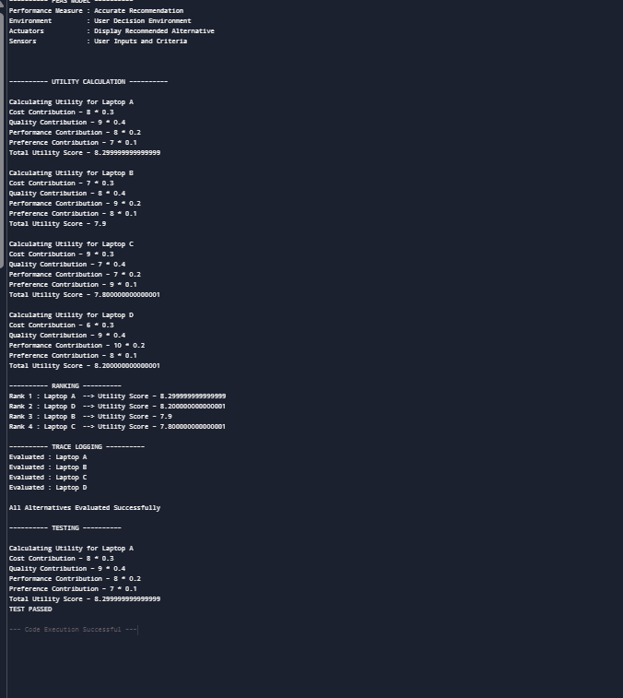

CO2 – Search Algorithms and Heuristics

How CO2 is used in the project
Search techniques are used to identify the best alternative among many possible options.

Applications in the Project

1. Search Algorithms
Concepts of:
- BFS
- DFS
- Uniform Cost Search
- Greedy Search
- A* Search
can be applied to explore and compare alternatives systematically.
Example:
- Searching for the best college or laptop option from many available choices.

2. Heuristic Design
Heuristics are used to estimate the best option faster.
Example heuristics:
- Lower cost preferred
- Higher rating preferred
- Better performance preferred
The heuristic function helps reduce unnecessary comparisons.

3. Open and Closed Sets
- Open set → Alternatives yet to be evaluated
- Closed set → Already evaluated alternatives
This improves efficiency in decision-making.

4. Tie-Breaking Strategy
If two alternatives have similar utility scores:
- Higher priority criterion is used for final selection.

5. Empirical Profiling
The project measures:
- Runtime
- Number of evaluated alternatives
- Memory usage
- Recommendation accuracy
to analyze system performance.
Results/Screen Shot
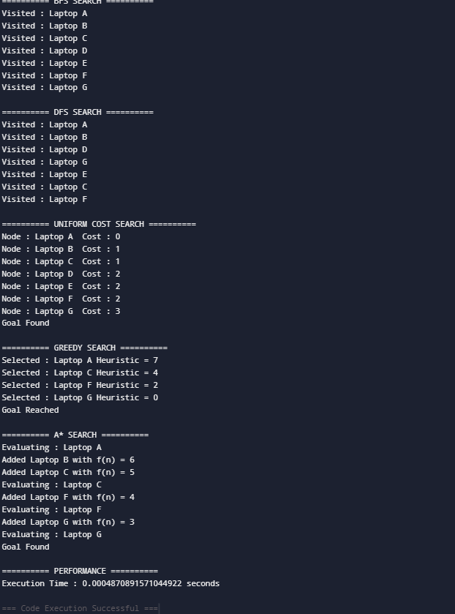

CO3 – Constraint Satisfaction Problems (CSP)

How CO3 is used in the project
The project models decision-making as a Constraint Satisfaction Problem.

Applications in the Project

1. CSP Modeling
User requirements act as constraints.
Example:
- Budget < ₹50,000
- Rating > 4 stars
- Distance < 10 km
The system only selects alternatives satisfying these constraints.

2. Backtracking
If an alternative fails to satisfy constraints:
- The system backtracks and checks another option.

3. Constraint Propagation
Techniques like:
- Forward checking
- Arc consistency intuition
help eliminate invalid alternatives early.

4. Heuristics (MRV, Degree, LCV)
The project can use:
- MRV → Choose the most restrictive criterion first
- Degree heuristic → Prioritize highly connected constraints
- LCV → Choose options causing minimum conflicts

5. Local Search (Min-Conflicts)
If conflicts exist among criteria:
- The system searches for alternatives with minimum conflicts.
Example:
- Balancing low cost and high quality.

6. Scheduling and Timetabling Concept
The same system idea can be extended to:
- Course scheduling
- Timetable generation
- Resource allocation

7. Explainability
The system explains why an alternative failed.
Example:
“Laptop A rejected because price exceeds budget.”
This improves transparency and user understanding.
Results/Screen Shot
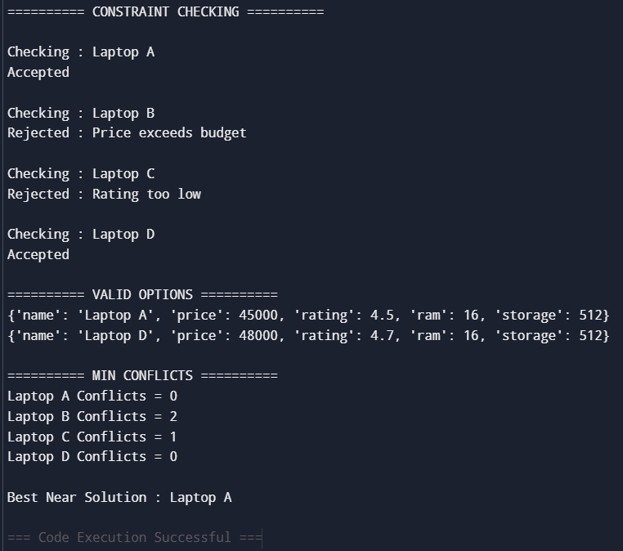

CO4 – Utility-Based Decision Making and Game Strategies

How CO4 is used in the project
The project uses utility-based reasoning to select the best alternative among multiple choices while handling trade-offs and uncertain conditions.

Applications in the Project

1. Utility Functions
The system calculates utility scores for each alternative based on weighted criteria such as:
- Cost
- Quality
- Performance
- User preference
Higher utility indicates a better decision option.

2. Minimax Concept
The minimax idea can be applied in situations where the system must minimize risks while maximizing benefits.
Example:
- Choosing a product with the best balance between price and quality while avoiding worst-case choices.

3. Alpha-Beta Pruning
Alpha-beta pruning concepts help reduce unnecessary evaluations while comparing alternatives, improving system efficiency.

4. Evaluation Functions
The project uses evaluation functions to score and rank alternatives based on:
- Utility values
- Constraint satisfaction
- User priorities

5. Depth Limits and Iterative Deepening
The system can limit the number of explored alternatives to reduce computation time. Iterative deepening concepts can help progressively improve recommendations.

6. Stochastic Decisions (Expectimax Concept)
The project can handle uncertain situations where outcomes are probabilistic.
Example:
- Product ratings may vary based on user reviews and market trends.
The system estimates expected utility before making recommendations.

7. Bounded Rationality
Since real-world decisions have limited time and information, the system selects the best possible option within available constraints rather than searching infinitely.

8. Policy Selection
The decision agent follows policies such as:
- Prefer low cost when budget is limited
- Prefer quality when performance is prioritized

9. Multi-Agent Reasoning Basics
The project can simulate multiple viewpoints or preferences from different users while selecting the best alternative.
Example:
- Parent prefers low cost
- Student prefers better quality
- Results/Screen Shot
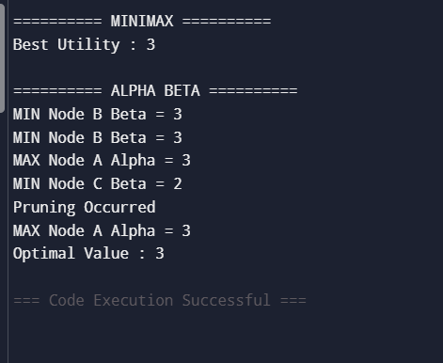

CO5 – Probabilistic Reasoning and Uncertainty Handling

How CO5 is used in the project
The project uses probabilistic reasoning to make decisions under uncertainty.

Applications in the Project

1. Probability Concepts
The system uses probability values to estimate how likely an alternative satisfies user expectations.
Example:
- Probability that a product is reliable based on reviews.
Bayes Rule helps update decision confidence when new information becomes available.
Example:
- Updating laptop recommendations after receiving new ratings or reviews.

3. Bayesian Networks
The project can model relationships among factors such as:
- Price
- Quality
- Customer satisfaction
- Reliability
using probabilistic dependency structures.

4. Inference by Variable Elimination
The system can eliminate irrelevant variables while calculating the probability of selecting the best alternative, improving efficiency.

5. Belief Propagation Intuition
The decision agent updates beliefs dynamically as new user inputs or constraints are added.

6. Sampling Inference
Concepts such as:
- Rejection sampling
- Likelihood weighting
can help estimate probabilities when complete information is unavailable.

7. Markov Chains and HMM Intuition
The project can model changing user preferences over time.
Example:
- Tracking how user priorities change from low-cost products to high-performance products.

8. Sensor Fusion Reasoning
The system combines multiple information sources such as:
- User reviews
- Ratings
- Specifications
- Expert opinions
to improve decision accuracy.

9. Uncertainty-Aware Decisions
The project uses expected utility concepts to make decisions even when information is incomplete or uncertain.
Example:
- Selecting the safest recommendation with the highest expected satisfaction.

- Results/Screen Shot

- 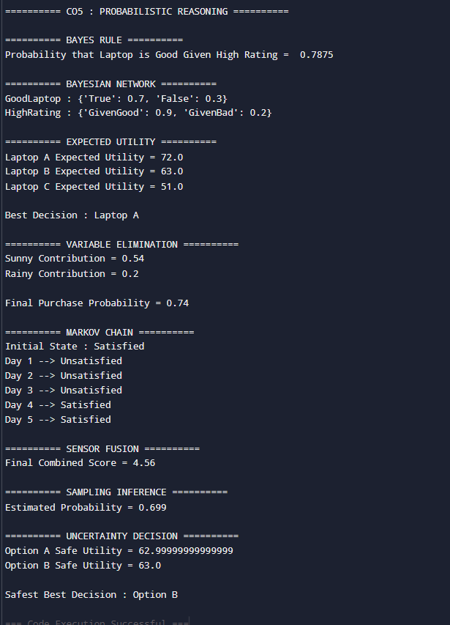

CO6 – Hybrid Intelligent Decision System

How CO6 is used in the project
The project integrates multiple AI techniques into one intelligent decision-making framework.

Applications in the Project

1. Combining Search + CSP + Probabilistic Inference + Decision Logic
The system combines:
- Search algorithms for exploring alternatives
- CSP techniques for handling constraints
- Probabilistic reasoning for uncertainty
- Utility-based logic for final recommendations
This creates a complete intelligent decision support system.

2. Hybrid Architecture
The project uses a hybrid AI architecture combining:
- Rule-based reasoning
- Search techniques
- Probabilistic methods
Example:
- Rules filter invalid options
- Search finds the best alternatives
- Probability handles uncertainty

3. Explainable Reasoning Traces
The system provides explanations for recommendations.
Example:
“Laptop B selected because it satisfies budget, performance, and rating constraints.”
This improves transparency and user trust.

4. Performance Engineering
The project evaluates:
- Runtime efficiency
- Memory usage
- Recommendation accuracy
- Scalability
to improve system performance.

5. Failure Analysis
The system analyzes cases where recommendations may fail due to:
- Incomplete data
- Conflicting criteria
- Incorrect weights
- Uncertain information

6. Ethics and Limitations
The project considers technical limitations such as:
- Bias in heuristic scoring
- Incorrect probability estimation
- Overdependence on user-provided data
This ensures responsible AI-based decision-making.

7. Readiness for Advanced AI Areas
The project builds foundational knowledge useful for future learning in:
- Machine Learning
- Deep Learning
- Natural Language Processing
- Generative AI systems
- It demonstrates how multiple AI concepts work together in real-world applications.
- Results/Screen Shot
- 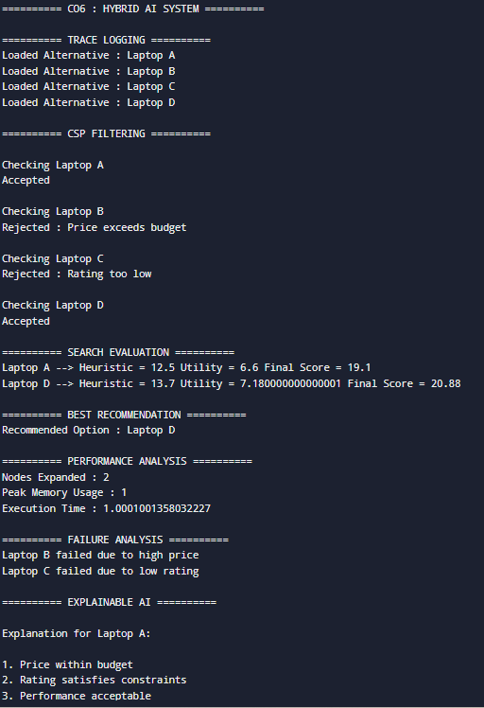
- 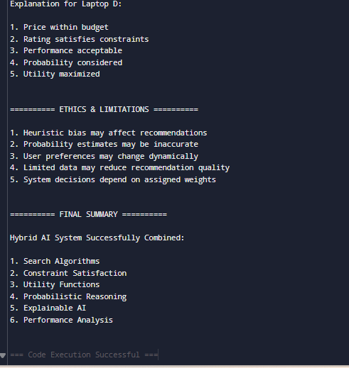

Top of Form
Bottom of Form

